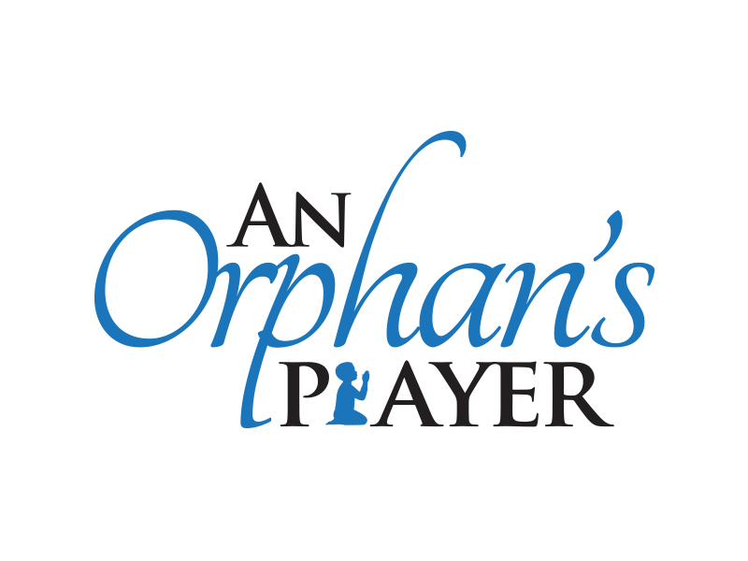

March 25, 2012 (Change date)
Dear ________,
I am so excited for an opportunity I have to serve the Lord on a mission trip sponsored by An Orphan’s Prayer (AOP). Our group of 10-20 people will be gone from (fill in blank). We are going to serve in Haiti in various orphanages. An Orphan’s Prayer is an orphan care ministry 501c3.
The focus of our trip is simple – help these kids recover and rejoice again. The children have lost their parents or have simply been abandoned. Activities will include playing, singing, games, crafts, loving, hugging and holding. The simple act of loving these children, or becoming their family for (fill in blank) days, is just like treating a physical wound. During our visit, we will also have an opportunity to worship with the local church in Haiti, as well as be exposed to a third world country in need. Our group will also carry down clothing, shoes and other supplies that will be distributed to orphanages throughout Haiti. There will be an opportunity for our group to bring it’s individual gifts. Many times AOP helps paint, hang curtains, relieve the onsite momma, or even set-up a VBS or medical clinic. I will keep you updated when I return and the ways in-which the Lord uses our gifts down in Haiti.
One of the ways you can help me is to pray for the trip, the ministry we will perform, and for me personally. Only with prayer support will I be able to bless the children in the orphanage.
The other way to assist me is through your financial support. The cost of the trip is $750.00 plus airfare to/from Haiti. Your contribution will allow me the privilege of participating and is a tax deductible donation. If this is something you can help me with; Please make your check payable to An Orphan’s Prayer and return it to me (or send to the address below). I will submit it to the organization once I have collected all funding for my trip. If I am unable to participate in the trip, your gift will be used to support the orphan care ministry, through An Orphan’s Prayer Foundation.
God is transforming lives through the care provided to orphaned and abandoned children around the world. I am humbled to be joining Him in this work.
God bless,
Your Name

